SQL DATABASE WITH PYTHON
AGENDA:
- SQL DB CONNECTIONS
- READ DATA FROM SQL DB
- CONSTRUCT DATAFRAMES & LOAD SOURCE DATA AT ONCE
- TRANSFORMATIONS WITH DATAFRAMES
- WRITE DATA FROM SQL DB / DWH

HOW TO CONNECT & OPERATE ON SQL DATABSE USING PYTHON?
STEP 1: INSTALL PYDODBC DRIVER (VERSION 17 OR 18)
STEP 2: VERIFY THE DRIVER INSTALLATION
STEP 3: ESTABLISH THE CONNECTION TO SQL DATABASE
STEP 4: QUERY THE DATABASE, TABLES. PEFORM REQUIRED SQL OPERATIONS

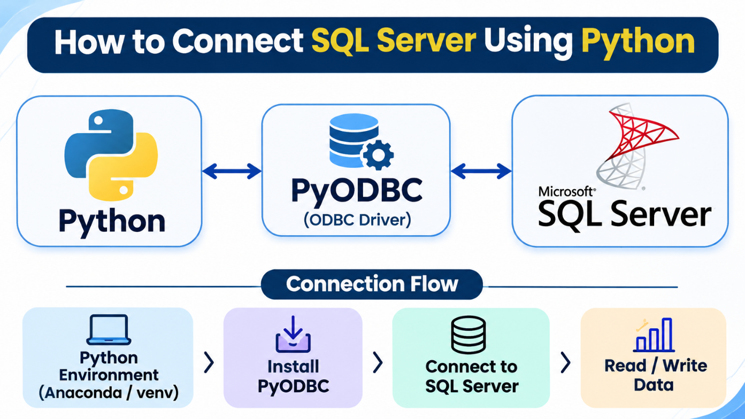

POSSIBLE OPTIONS TO READ DATA FROM SQL DATABASES USING PYTHON:
1. QUERY THE TABLE / REQUIRED COLUMNS DIRECTLY
2. QUERY THE DATABASE USING JOIN(S)
3. CONSTRUCT A VIEW IN THE DATABASE. USE IT IN PYTHON

AVANTAGES OF DATA ACCESS FROM PYTHON:
- FASTER DATA TRANSFORMATIONS
- EASIER APPLICATION ACCESS. THIS ENSURES DATA ABSTRACTION / SECURITY.
- EASIER DATA ENGINEERING & DATA ANALYSIS
- EASIER MACHINE LEARNING IMPLEMENTATION

REQ: HOW DO YOU ACCESS SQL DATABASE FROM PYTHON?
STEP 1: LAUNCH SSMS (SQL SERVER MANAGEMENT STUDIO)
CONNECT TO YOUR LOCAL SQL SERVER, DATABASE.
TEST FEW QUERIES ON EXISTING DATA.

STEP 2: LAUNCH ANACONDATA NAVIGATOR
NEW JUPYTER NOTEBOOK WE SEE ONE BROWSER WINDOW.
RUN THESE CELLS:

# Step 1: Install PYODBC Driver
%pip install pyodbc pandas

# Step 2: Import PYODBC Driver into Notebook
import pyodbc
print(pyodbc.drivers())

# Step 3: Define Connections to SQL Database
import pyodbc #This Python module is used to establish connections to SQL Database
import pandas.io.sql as psql #This Python module is used to execute queries on SQL Database
import pandas as pd #To perform Transformations (Ex: Merge) on SQL Database
cnxn = pyodbc.connect(driver='{ODBC Driver 18 for SQL Server}',
server = 'SQLSCHOOL2\SERVER1',database='PRODUCTDATABASE',UID='sa',PWD='admin123$')

# Step 4: Connect to SQL Database, Run Query For Table 1, Load to a Dataframe
cursor = cnxn.cursor()
cursor.execute("SELECT ProductKey, EnglishProductName, ListPrice FROM PRODUCTS_DATA WHERE COLOR = 'RED' ")
columns = [col[0] for col in cursor.description]
rows = cursor.fetchall()
df1 = pd.DataFrame.from_records(rows,columns=columns)
display(df1)

# Step 5: Connect to SQL Database, Run Query For Table 1, Load to a Dataframe
cursor = cnxn.cursor()
cursor.execute("SELECT * FROM SALES_DATA")
columns = [col[0] for col in cursor.description]
rows = cursor.fetchall()
df2 = pd.DataFrame.from_records(rows,columns=columns)
display(df2)

# Step 6: Merge above two Dataframes using Python. Write to 3rd dataframe, verify result.
df3 = pd.merge(df1, df2)
display(df3)

For Doubts & Clarifications: Please reach me on +919030040801
https://www.linkedin.com/in/saiphanindra/

