Python Introduction
  - Python for Developers, Data Analysts & Data Engineers

1. What is Python?
Python is a high-level, general-purpose programming language known for readable syntax and a large ecosystem of libraries. A Python program is a set of instructions that a computer runs to solve a problem.
Python is general-purpose programming language widely used for software development, data analytics, data engineering, automation, artificial intelligence (AI), and machine learning (ML).

2. History of Python?
Python was created in 1989 to make programming simple. Today, it has evolved into one of the most important programming languages for Data Analysts, Data Engineers, Cloud Engineers, and AI Engineers
 | Creator: Guido van Rossum  Country: Netherlands  Development Started: December 1989  First Release: February 1991  Organization: Centrum Wiskunde & Informatica (CWI)  Name Inspired By: Monty Python's Flying Circus,  a British comedy television show.

Python Evolution – Important Milestones
Year | Milestone
1989 | Guido van Rossum developing Python as a successor to the ABC programming language.
1994 | Python 1.0 was released.
2001 | Python Software Foundation (PSF) was established.
2008 | Python 3.0 was released with major improvements and language changes.
2010s | Python became increasingly popular in Data Science, AI, ML, and Big Data.
2020s | Python became central to cloud data engineering, automation, AI, and analytics platforms.

Why Was Python Developed?
Mr. Guido van Rossum wanted a programming language that was:
- Easy to learn: Simple syntax similar to English.
- Easy to read: Clean, understandable programs.
- Productive: Accomplish tasks using fewer lines of code.
- Flexible: Suitable for small scripts and large applications.
- Extensible: Integrates with other languages and technologies.
- Cross-platform: Runs on Windows, Linux, and macOS.

3. How Python became part of our daily Job?
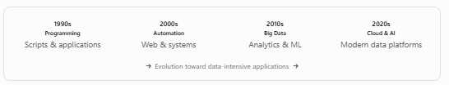

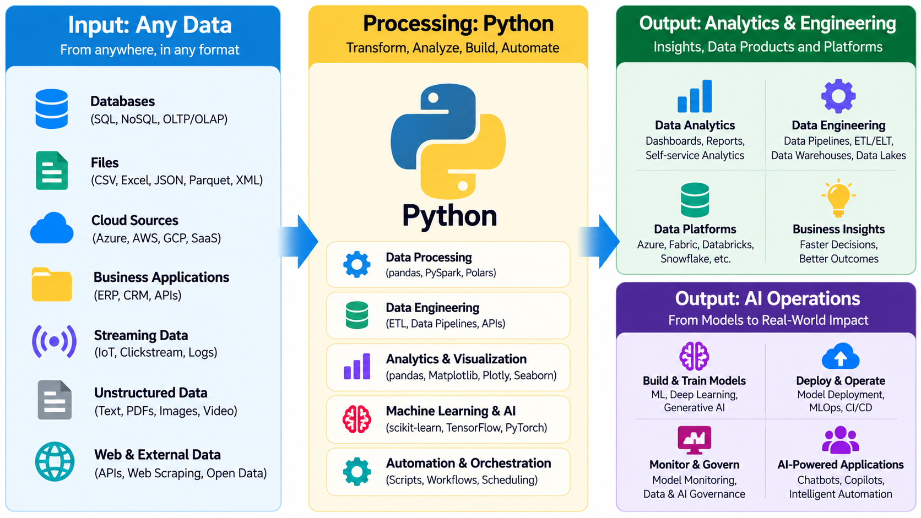
Python is the common skill; Azure, Fabric, Databricks and Snowflake give us different execution and orchestration environments.

4. Where is Python extensively Used?
- Microsoft Azure: Cloud automation, data integration, and data engineering.
- Microsoft Fabric: Python notebooks, PySpark transformations and analytics.
- Databricks: Distributed data processing, Delta Lake, ETL and machine learning.
- Snowflake: Snowpark Python, data transformations and stored procedures.

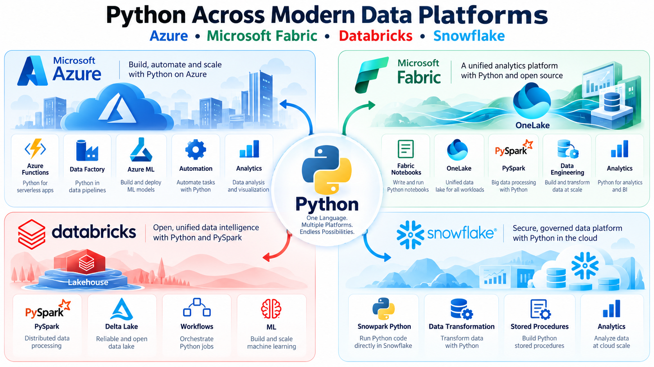

5. Who uses Python?
Python is one of the most popular programming languages, widely used by IT professionals for Data Analytics, Data Engineering, Automation, Cloud Computing, Artificial Intelligence (AI), and Machine Learning (ML).
Python is an essential across modern data platforms, helping professionals process data, automate workflows, develop analytics solutions, and build AI-powered applications.
Major Job Roles Using Python
Job Role | How Python Is Used
1. Data Analyst | Data cleaning, transformation, analysis, reporting, and visualization using pandas, NumPy, and Matplotlib.
2. Data Engineer | Build ETL/ELT pipelines, automate data processing, integrate APIs, and process large datasets. Medallion Architecture
3. Data Scientist | Statistical analysis, predictive modeling, machine learning, and data exploration.
4. AI / ML Engineer | Develop, train, test, and deploy machine learning and AI applications.
5. Cloud / DevOps Engineer | Automate cloud infrastructure, deployments, monitoring, and operational tasks.
6. Software Developer | Develop backend applications, REST APIs, web services, and automation tools.
7. Business Analyst | Automate Excel tasks, analyze business data, and generate reports and insights.

Python + SQL + Cloud Data Platform = Strong Foundation for Modern Data Careers

6. Python Libraries and Technologies by Career
Career Path | Python Technologies & Libraries
Data Analyst | pandas, NumPy, Matplotlib, Seaborn
Data Engineer | pandas, PySpark, APIs
Azure Data Engineer | pandas, Azure SDK, PySpark
Fabric Data Engineer | pandas, PySpark, Fabric Notebooks
Databricks Engineer | pandas, PySpark, Delta Lake
Snowflake Engineer | pandas, Snowpark
AI / ML Engineer | pandas, scikit-learn, PyTorch, TensorFlow
Automation Engineer | pandas, requests, Selenium

+91 9030040801

7. How to work with Python?
Option 1: Local Computer (Windows / Linux / Mac)
Option 2: Development Tools (Anaconda / Visual Studio)
Option 3: Online Platfroms (Google Colab, Kaggle, Replit)
Option 4: Enterprise Cloud (Azure, Fabric, Databricks, Snowflake)

Option 1: How to Install Python on Windows – Step by Step
- Visit Python.org Downloads
- Download the recommended Windows Python installer or Python Install Manager.
- Run the installer and complete the setup.

Option 2: How to Install Python Using Anaconda App?
- Visit Anaconda Download
- Download and install Anaconda
- Open Anaconda Navigator
- Launch JupyterLab or Jupyter Notebook
- Create a Python notebook Execute

Option 3: Run Python Without Installing Anything
- Google Colab
- Sign in with a Google account
- Create a Python notebook Execute

Option 4: Run Python in Azure, Fabric, Databricks and Snowflake
- Sign Up / Sign in to desired Cloud Platform
- Set up the Environment for Resource Allocation
- Create Notebook Execute

SQL School | Python Trainings & Projects | https://sqlschool.com

