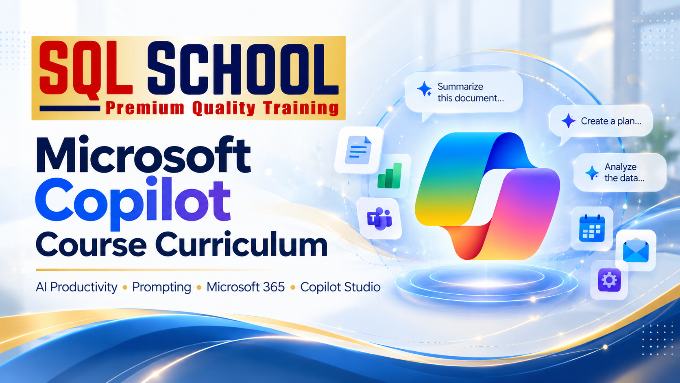

Learn → Prompt → Automate → Build Agents → Deploy

Course Overview
A hands-on, beginner-to-intermediate course focused on using Microsoft Copilot for everyday work, building useful AI assistants, and creating low-code agents for business processes. The course distinguishes Microsoft Copilot Chat, licensed Microsoft 365 Copilot experiences, and Microsoft Copilot Studio.
Suggested duration | 6 weeks | 36 instructor-led hours + guided practice
Learning mode | LIVE online / classroom / corporate workshop
Audience | Students, IT professionals, analysts, managers, support teams, business users
Prerequisites | Basic computer and Microsoft 365 familiarity; no coding required for core track
Lab access | Eligible Microsoft 365 account; Microsoft 365 Copilot and Copilot Studio licenses/trials where required
Outcome | Productivity workflows, reusable prompts, 2 guided projects and 1 capstone agent

Learning Outcomes
- Explain Copilot products, AI fundamentals, grounded answers and common limitations.
- Write, test and refine reusable prompts for workplace scenarios.
- Apply Copilot in Word, Excel, PowerPoint, Outlook, Teams and enterprise search where licensed.
- Build a low-code knowledge-based agent using Copilot Studio and connect simple workflows.
- Apply security, access permissions, governance, responsible AI and response evaluation.
- Present a demonstrable AI productivity and agent automation capstone.

Module 1 — Microsoft Copilot & Generative AI Fundamentals

Chapter 1. AI Foundations
- AI, machine learning, generative AI and large language models
- How prompts, context and output generation work
- Hallucinations, accuracy, grounding and human review
- Typical workplace use cases and limitations

Chapter 2. Microsoft Copilot Ecosystem
- Microsoft Copilot consumer experiences versus Microsoft 365 Copilot Chat
- Microsoft 365 Copilot in work apps and the role of Microsoft Graph
- Microsoft Copilot Studio and agent use cases
- Overview of GitHub Copilot and Microsoft Security Copilot (orientation only)

Chapter 3. Setup, Access & Licensing
- Work/school account and Microsoft 365 tenant concepts
- Licensing and feature availability overview
- Copilot entry points, user interface and settings
- Lab readiness checklist and data safety rules

Module 2 — Prompt Engineering for Copilot

Chapter 4. Writing Better Prompts
- Goals, context, source information and desired format
- Role, tone, audience and output constraints
- Zero-shot, few-shot and stepwise prompting
- Prompt templates for recurring work

Chapter 5. Advanced Prompt Workflows
- Prompt iteration and follow-up questions
- Summarization, extraction, classification and rewriting
- Comparing options and requesting evidence/citations
- Evaluating outputs with a practical quality checklist

Chapter 6. Prompting Lab
- Draft professional emails and meeting agendas
- Create a project plan and status update
- Summarize lengthy documents with source checking
- Build a personal prompt library

Module 3 — Microsoft 365 Copilot for Productivity

Chapter 7. Copilot in Word
- Create first drafts, summaries and rewrites
- Adjust voice, clarity, structure and length
- Work with source documents where supported
- Review generated content and factual accuracy

Chapter 8. Copilot in Excel
- Describe data trends and request analysis
- Explore formulas, tables and visual summaries
- Interpret results and cross-check calculations
- Practice with sample sales and operations data

Chapter 9. Copilot in PowerPoint
- Build presentation outlines and draft slides
- Summarize decks and refine slide messaging
- Create speaker notes and adapt audience tone
- Review design and data integrity

Chapter 10. Copilot in Outlook & Teams
- Draft, summarize and prioritize email conversations
- Prepare meetings and summarize discussions
- Identify action items and follow-up tasks
- Understand meeting transcription/recording prerequisites

Chapter 11. Microsoft 365 Search & Collaboration
- Finding organizational information within access permissions
- Working with SharePoint and OneDrive content
- Grounding, references and permission boundaries
- Cross-application productivity scenarios

Module 4 — Copilot Chat & Agent Builder

Chapter 12. Working with Copilot Chat
- Web-grounded and work-grounded experiences
- Files, context and supported chat capabilities
- Creating structured reusable conversations
- Checking references and data boundaries

Chapter 13. Introduction to AI Agents
- Chat assistants versus task-oriented agents
- Agent instructions, knowledge, tools and actions
- Agent scope, personas and guardrails
- When an agent is the right solution

Chapter 14. Build a Simple Agent
- Define agent objective and user questions
- Create a declarative agent using available builder tools
- Attach approved knowledge sources where supported
- Test responses and refine instructions

Module 5 — Microsoft Copilot Studio: Agent Development

Chapter 15. Copilot Studio Fundamentals
- Environments, agent creation and authoring interface
- Agent instructions, orchestration and configuration
- Standard authoring concepts and feature differences
- Create a customer-support or course-enquiry agent

Chapter 16. Knowledge & Conversations
- Add approved websites, files and connected knowledge
- Ground answers and address unsupported questions
- Topics, variables and conversation branches
- Fallbacks, escalations and safe response design

Chapter 17. Tools, Actions & Automation
- Overview of tools, connectors and agent flows
- Basic Power Automate integration concepts
- Capture user inputs and invoke a permitted action
- Error handling, confirmation and human handoff

Chapter 18. Test, Publish & Monitor
- Test cases and response validation
- Publish to supported channels based on licensing
- Analytics, user feedback and response improvement
- Versioning, maintenance and release checklist

Module 6 — Enterprise Readiness & Responsible AI

Chapter 19. Microsoft 365 Security Foundations
- Microsoft Entra identity and least-privilege access
- Microsoft Graph and existing data permissions
- SharePoint/OneDrive content hygiene and oversharing
- Sensitive data handling and organizational policy

Chapter 20. Responsible AI & Governance
- Privacy, fairness, transparency and accountability
- Prompt injection, inaccurate answers and misuse risks
- Human-in-the-loop approvals and quality reviews
- Audit, data retention and governance overview

Chapter 21. Adoption & ROI
- Identify high-value productivity workflows
- Measure time saved and output quality
- Create prompt/agent adoption playbooks
- Plan support and ongoing improvement

Module 7 — Guided Real-Time Projects

Chapter 22. Project 1: Productivity Accelerator
- Create a reusable business prompt library
- Summarize a project brief and prepare an executive update
- Build a presentation and professional email follow-up
- Deliver outputs with an accuracy and privacy checklist

Chapter 23. Project 2: Knowledge Assistant
- Define FAQs for HR, IT support or training enquiries
- Create an agent with approved knowledge documents
- Test known, unknown and sensitive questions
- Deliver a demo plus test evidence

Module 8 — Capstone, Assessment & Career Applications

Chapter 24. Capstone: Business Process Agent
- Select a use case and write the requirement document
- Configure agent instructions, knowledge and conversation flow
- Connect one simple approved action or escalation path
- Test, demonstrate and document limitations

Chapter 25. Assessment & Portfolio
- Prompt engineering practical assessment
- Copilot productivity task demonstration
- Agent build, test and presentation rubric
- Prepare project README, screenshots and portfolio summary

Chapter 26. Roles, Next Steps & Certification Guidance
- Copilot champion and business productivity roles
- Copilot Studio maker and automation pathways
- Microsoft Learn practice resources and role-based learning
- Certification mapping subject to current Microsoft exam catalog

Program Duration: 1.5 Months
Training Mode: LIVE, Online
Enroll Today for Free Demo. Reach us on +91 9951440801
www.sqlschool.com

